
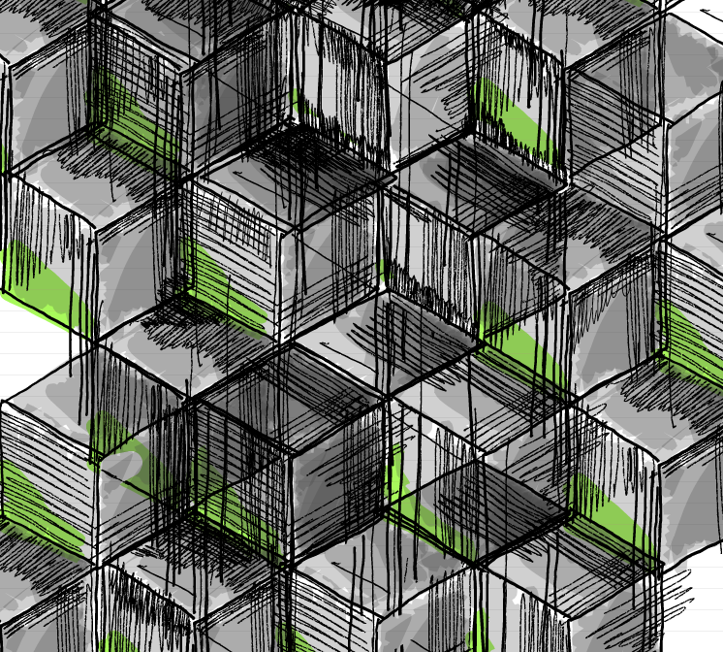

Cube Test 1 Friday 25th October 2024
CUBE TRANSCONFIGURATION TOOL
“What is so exciting for me about object-based learning; it helped me to I understand that you can create new ways in communicating ideas and information, stimulate deeper learning and new ways of thinking through the use of an object; how it influences one’s thoughts when a person is holding it in their hands”.

‘The variations in how information can be transmitted; abstract ideas and thinking can be made simpler or complicated. Transferable skills can be developed through the manipulation of materials, the way we talk about materials and its understanding of it. How certain objects made or found can create meaning and engage people from different cultures and nationalities.’
I want this research to promote a new way of thinking in how objects are placed in a space, holds or contains information, how it provokes thinking and understanding. To observe how we learn, how we engage with each other and communicate and share transferable skills learnt during the research teaching session.

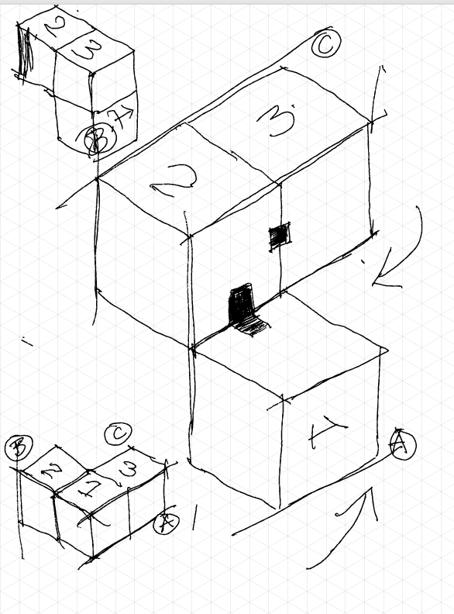
Construction design ideas in how the cube parts are hinged.
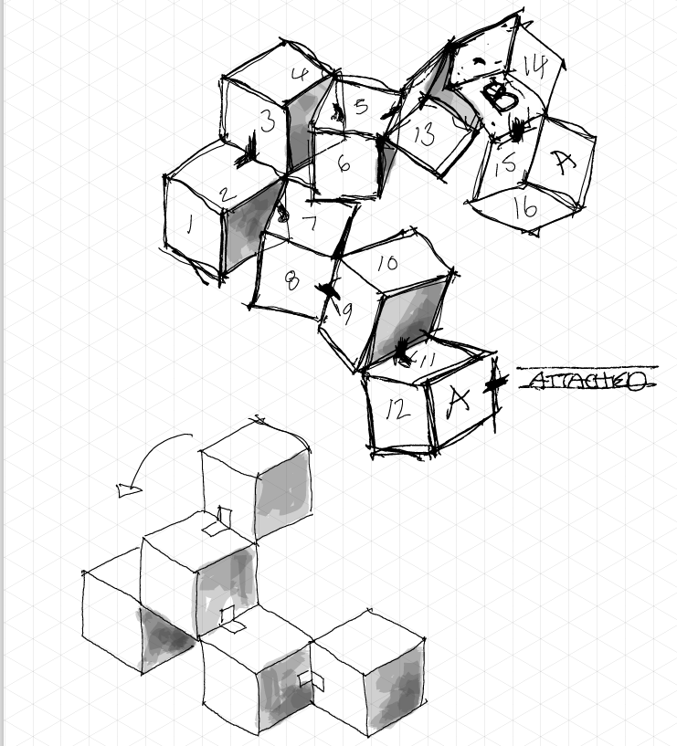
Placement of cubes attached together and configuration design possibilities.
The cube will be introduced in class as a hands-on tool to encourage open dialogue about unseen disabilities and other challenges students may face. Here’s how the process will unfold:
- Presentation: The teacher will start by explaining the purpose of the cube and its role in fostering inclusivity. They will highlight how the cube can help reveal and discuss unseen disabilities, faith, and racism.
- Demonstration: The teacher will show how the cube can be manipulated into different configurations, using images or a live demonstration. This will help students understand how to interact with the cube.
- Engagement: Each student will receive a cube to explore. They will be encouraged to write or draw on the blank surfaces of the cube, expressing any unseen challenges they face.
- Discussion: The class will then engage in a group discussion, using the cubes as a starting point. Students can share their thoughts and experiences, fostering a supportive and inclusive environment.
- Feedback: The teacher will gather feedback from students on their experience with the cube, which will be used to refine the tool and improve future lessons.
This approach aims to create a safe space for students to express themselves and receive the support they need.
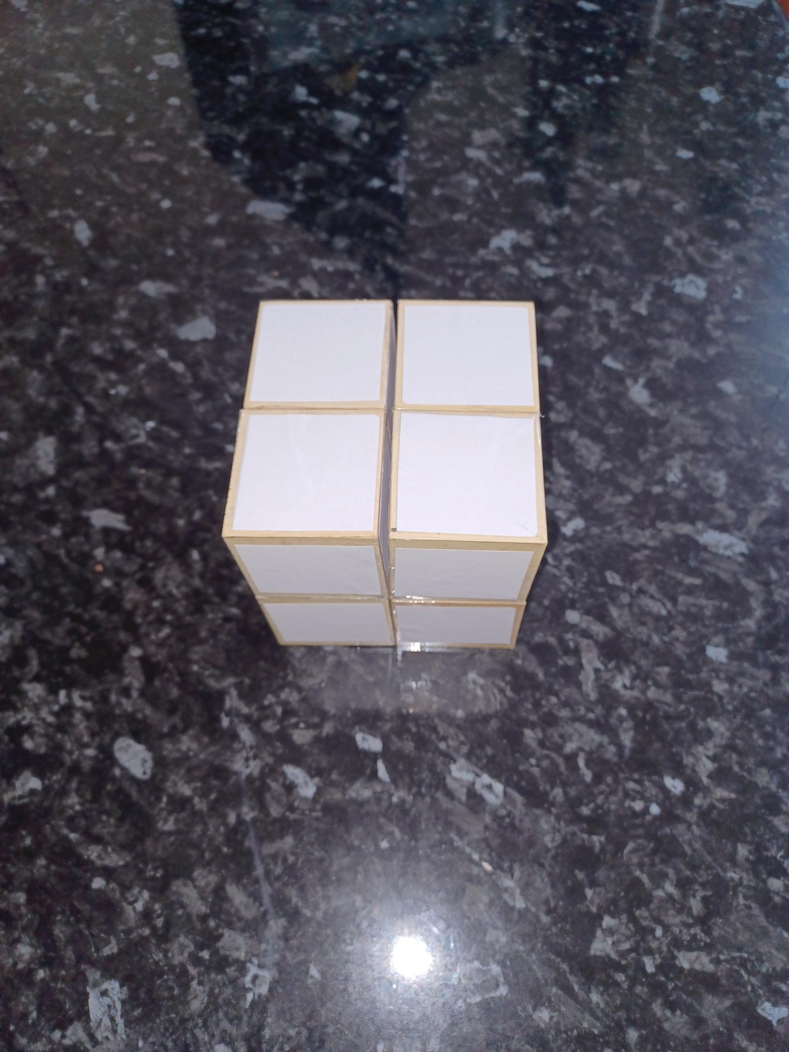
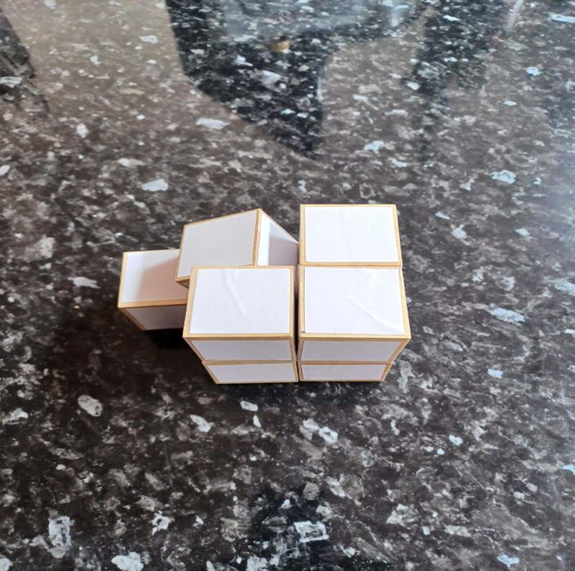
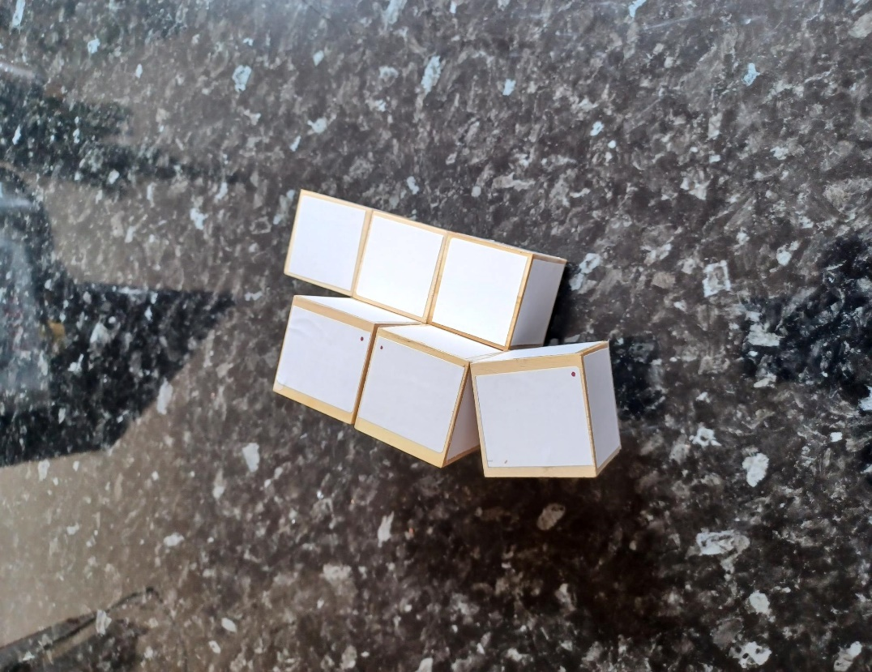

How will I address any potential discomfort or embarrassment for students using the cube?

Addressing potential discomfort or embarrassment for students using the cube is crucial to creating a supportive and inclusive environment. Here are some strategies that I will use to ensure students feel comfortable:

- Confidentiality: Emphasize that any information shared using the cube will be treated with confidentiality. Students should feel assured that their personal challenges will not be disclosed without their consent.
- Voluntary Participation: Make it clear that participation is voluntary. Students should not feel pressured to share more than they are comfortable with.
- Anonymous Sharing: Allow students to write or draw on the cube anonymously if they prefer. This can help them express their challenges without feeling exposed.
- Supportive Environment: Foster a classroom culture of respect and empathy. Encourage students to listen without judgment and support each other.
- Private Discussions: Offer the option for students to discuss their challenges privately with the teacher if they are not comfortable sharing in a group setting.
- Clear Instructions: Provide clear instructions on how to use the cube and the purpose behind it. This can help reduce anxiety about the activity.
- Positive Reinforcement: Acknowledge and appreciate students’ willingness to share their experiences. Positive reinforcement can help build a trusting and open classroom environment.
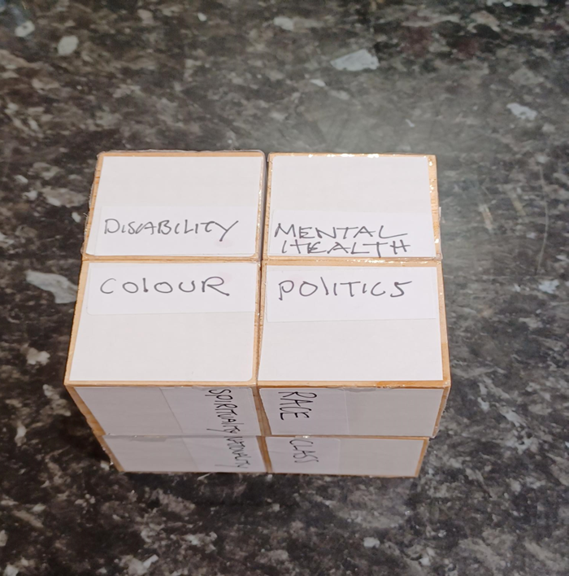
By implementing these strategies, I can help ensure that students feel safe and supported when using the cube to express their unseen challenges.
To enhance the use of the cube and support inclusivity, several additional technologies can be integrated into each step of the process:
- Presentation:
  - Interactive Whiteboards: Use interactive whiteboards to display information about the cube and its purpose. This can include videos, diagrams, and live annotations to make the presentation more engaging.
  - Augmented Reality (AR): Implement AR apps that allow students to visualize the cube in 3D and see examples of how it can be used.
- Demonstration:
  - Document Cameras: Utilize document cameras to project a live demonstration of the cube manipulation onto a screen, ensuring all students can clearly see the process.
  - Virtual Reality (VR): Create a VR simulation where students can practice manipulating the cube in a virtual environment before handling the physical object.
- Engagement:
  - Tablets or Laptops: Provide tablets or laptops for students to digitally document their thoughts and drawings on the cube. This can also include apps that allow for digital manipulation of a virtual cube.
  - Assistive Technology: Ensure that students with disabilities have access to assistive technologies, such as speech-to-text software or screen readers, to help them engage with the activity.
- Discussion:
  - Online Collaboration Tools: Use platforms like Microsoft Teams or Google Classroom to facilitate online discussions, allowing students to share their experiences and reflections in a digital space.
- Feedback:
  - Digital Surveys: Create digital surveys using tools like Google Forms or SurveyMonkey to collect detailed feedback from students about their experience with the cube.
  - Learning Management Systems (LMS): Use an LMS to track student progress, gather feedback, and provide additional resources related to inclusivity and the cube activity.
By integrating some of these technologies, I can create a more dynamic and inclusive learning environment that supports all students in expressing their challenges and receiving the support they need.

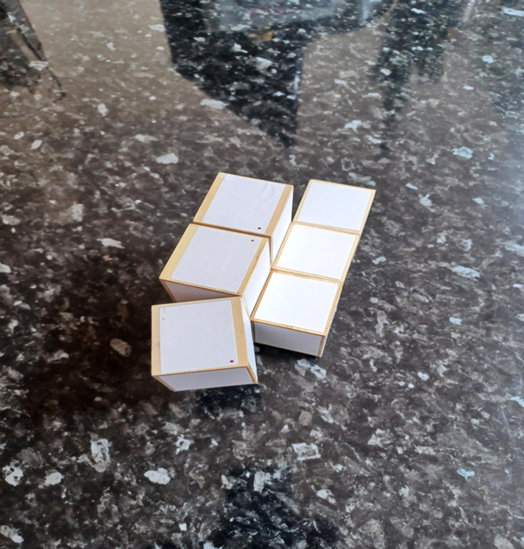

Questionnaire
Conclusion
Feedback from class

- QUESTIONS:
Did this research session (observation) make you think about how you teach?
- Did you observe, discover/develop creative ways in how information was gathered and learnt.
- How was this information/data attached to the cube surfaces. i.e. written on surface, coloured tape stuck on surfaces etc.
- Did they understand the aims of the class learning outcomes?
- Students to complete a questionnaire at the end of the session

Polling and Survey Tools: Implement tools like Mentimeter or Kahoot! to gather real-time feedback and opinions from students during the discussion

Some Questions to help students reflect on and understand disabilities:
- What do you think the term “disability” means?
- Can you name some different types of disabilities?
- How do you think disabilities can affect a person’s daily life?
- What are some common misconceptions about people with disabilities?
- How can society be more inclusive and supportive of people with disabilities?
- Have you ever met or known someone with a disability? What did you learn from them?
- What are some ways technology can help people with disabilities?
- Why is it important to use respectful language when talking about disabilities?
- How can schools and workplaces be made more accessible for people with disabilities?
- What can you do to support and advocate for people with disabilities in your community?
These questions can help foster a deeper understanding and empathy towards people with disabilities.

Some Questions to be used during research on unseen disabilities:
- What do you think the term “unseen disability” means?
- Can you name some examples of unseen disabilities?
- How might unseen disabilities affect a person’s daily life differently than visible disabilities?
- Why do you think unseen disabilities might be harder for others to understand or recognize?
- What are some challenges people with unseen disabilities might face in school or work environments?
- How can we support classmates or colleagues who have unseen disabilities?
- Why is it important to believe and respect someone when they say they have an unseen disability?
- How can we raise awareness about unseen disabilities in our community?
- What role does empathy play in understanding and supporting people with unseen disabilities?
- How can technology or accommodations help people with unseen disabilities?
These questions can help students develop a deeper understanding and empathy towards those with unseen disabilities. Is there a particular aspect of unseen disabilities you’re interested in exploring further?

