PGCERT BLOG !) REFERENCE my Disability

11 Responses to BLOG TASK #1 ‘DISABILITY’
- Yasaman Karbalaie Hadj Agha Tehrani says:
2nd May 2024 at 12:41 pm (Edit)
Hi Michael,
Your blog post on disability was a great read, and it prompted me to think deeply about the broad impact of societal structures on accessibility and inclusion. A lot of your thoughts speak to the ‘social model of disability’ is that something you’ve come across? I think your insights into the challenges faced by the d/Deaf community and the necessity for visual communication are compelling and highlight critical areas where we can improve inclusivity.
The example of systemic barriers like those that are unseen like autism, shows that we need to implement more robust strategies that promote understanding and integration at all levels of society. I’m curious about how you might go about implementing these changes in your role and in your educational context – are there specific strategies you’re considering in this respect?
Your ‘inclusion first approach’ really resonates with me and the work I do in my role, and ties into the Universal Design for Learning principles to ensure that we design for the margins.
Look forward to reading your future blogs for this unit Michael!
Reply
  - Michael Ste. Croix says:
26th May 2024 at 2:55 pm (Edit)
Dear Yasaman,
Thank you for your comments on my ‘Disability’ blog. Your thoughts on this are very welcomed.
The point you raised on about ‘social model of disability’ is an aspect that I have encountered around the accessibility for disabled students entering buildings (students with limited movement or are wheel chaired bound) and workshop facilities are not fully equipped to support students use of machinery and tools. Over the many years working at Central Saint Martins, these issues have been addressed, though it is an ongoing process to keep up to date with latest developments.
The unseen aspect of disability is a feature that I had not fully taken on board, and I do believe strategies must be put in place to encourage understanding and involvement at all levels in education and our communities.
I am thinking ‘Inclusion first approach’ should be one of UAL’s new motos…what do you think?
Reply
    - Yasaman Karbalaie Hadj Agha Tehrani says:
28th May 2024 at 10:42 am (Edit)
100% here for the ‘Inclusion first’ motto! Maybe we should make some t-shirts to spread the message… 😀
Reply
- Sidney Hope says:
8th May 2024 at 1:58 pm (Edit)
I agree with Michael discussing ‘systemic discrimination’ when it comes to provision for disabled students, I would extend this to all people most affected by disability, as society doesn’t start from a position of accessibility for all, rather for those who do not face health-related inequalities or discrimination based on inequality.
The Social Model of Disability relates to Michael’s point about the invisibility of different experiences of disability – making the world accessible for all should be the aim.
Michael is interested in the visual communication methods of artist Christine Sun Kim, how info graphics can be used to engage a wider group of students.
I agree with Michael when he says that change has been slow when it comes to the relationship between disability and race and that ‘we must continue the fight for more inclusive policies and practices’.
It is true that a lack of awareness of, or attention to, intersectionality and matters of accessibility ‘prevents people to fully participate in community events and feel safe and equal in society’.
Michael says that a focus on non-verbal communication, ‘underscores the need for greater understanding and accommodation of different communication styles within the community.’ It is important to see how making learning materials accessible for all, for instance, prioritises accessibility in an important way.
Reply
  - Michael Ste. Croix says:
26th May 2024 at 2:28 pm (Edit)
Dear Sidney,
Thank you for your comments on my blog on ‘Disability’. Thank you for noting the point that societies views on disability and invisibility can be based on experience and that we must be aware of this so that accessibility should be available for all.
It is frustrating that any changes to take place to support the disable-is very slow and the affects of this can be disheartening and at times detrimental to the well-being of the disable person. as always we must rely on society and politics to change its view so that all are treated fairly.
Many thanks
Michael
Reply
    - Sidney Hope says:
6th June 2024 at 10:30 am (Edit)
Hi Michael,
It would be interesting to know how many disabilities are invisible, I think the proportion could be quite high.
Awareness raising in relation to the experience of people with disabilities seems really key as you suggest.
Best wishes,
Sid
Reply
- Michelle Ussher says:
18th May 2024 at 3:01 pm (Edit)
Hi Michael,
I enjoyed your post, and two areas that you connected with seem related to me. These are the info-graphic and non-verbal communication. In Fine Art Painting (Foundation) I had a deaf student who had two interpreters at all times. This situation was new to me and I was curious about the system that supported the economic cost of it. I assumed it was CSM however, I learned it was the borough who covered the cost, which I believe is available to students 18 and under. How this would effect a deaf student pursuing a BA I am unsure and it would be interesting to find out if the borough continues or if the individual covers the cost or the institution. What I learned, and also noticed Sun Kim doing on film without mentioning it, was when I was in tutorials or discussions with the deaf student I was asked to talk directly to them, not the translator, which at times was difficult as the student rarely made eye contact in our conversation as they needed to look at the translator. Sun Kim’s emphasis on movement and the inclusion of the “movement” graphic in her work resonated with me, as I noticed how necessary physical expression was when communicating with the deaf student. I wondered if when you mention info-graphics whether they could be created by deaf individuals as Sun Kim’s graphics had humour and character which others lack. Also, what is perhaps unsaid is how communicating through translators can also reduce the visibility of a deaf students personality. During a silent group crit when we used board.net I was struck by how playful and funny the deaf student was, which was a behavioural aspect not translated by the translators.
Reply
  - Michael Ste. Croix says:
26th May 2024 at 2:11 pm (Edit)
Dear Michelle,
Thank you for your comments on my ‘Faith’ blog, your thoughts on it are very helpful. I agree with you that financial support for disabilities is essential for students to progress in their education and it is important that institutes and local borough communities have systems in place to encourage this. I think both of us have been struck how Sun Kim has used her artistic craft and as powerful tool to communicate to society and make it aware of the deaf community. Graphic communication is a powerful tool in transmitting ideas and thoughts across to the deaf as well as the hearing.
Thank you for your observation on the impact of the ‘translators’ and how it can reduce the visibility of the deaf students personality. I have never though of a translator may stifle the deaf students ‘own voice’ but is is something that I will keep in mind.
Question: Is it our role to ( as hearing persons) encourage the deaf student to find their own voice to communicate without the aid of a translator?
This might be a controversial question as the ‘hearing person’ verses the ‘Deaf person’ has very complex , social and political intersections.
Reply
    - Michelle Ussher says:
28th May 2024 at 11:00 am (Edit)
Hi Michael,
I feel very fortunate to have worked with differently disabled students as each time they’ve shifted my perspective of their experience in our interactions. What I liked about Taylor and Butler’s video is how Taylor makes it explicit that she has an impairment and the world around her can be disabling. It shifts responsibility from the individual to a shared responsibility of the community. This is perhaps a lengthy way to respond to your question on our role in encouraging the visibility of a deaf students voice sans translator. A hearing student with signing skills nurtured a close friendship and this evidenced to me if I had similar skills I could reach the deaf student with more ease. As teacher’s I would like opportunities to expand my skillset in areas like signing, or methods for teaching neurodiversity, however these practical training resources seem absent. There seems a gap here as one might think it is more affordable to train teachers in signing than pay for multiple translators on a daily basis.
Reply
- Michael Ste. Croix says:
2nd June 2024 at 10:51 am (Edit)
Dear Michelle,
Totally agree with everything that you have said. External support; translators, sign language skills, are heavily dependent on college agreed financing/budgets.
Lets hope in the future that these resources will be available to support our students and staff.
Michael
Reply
- Michael Ste. Croix says:
2nd June 2024 at 12:11 pm (Edit)
I agree, I will talk to my costume team to see what the feasibility for them to be made. Why don’t we come up with a design

Below is my first approach
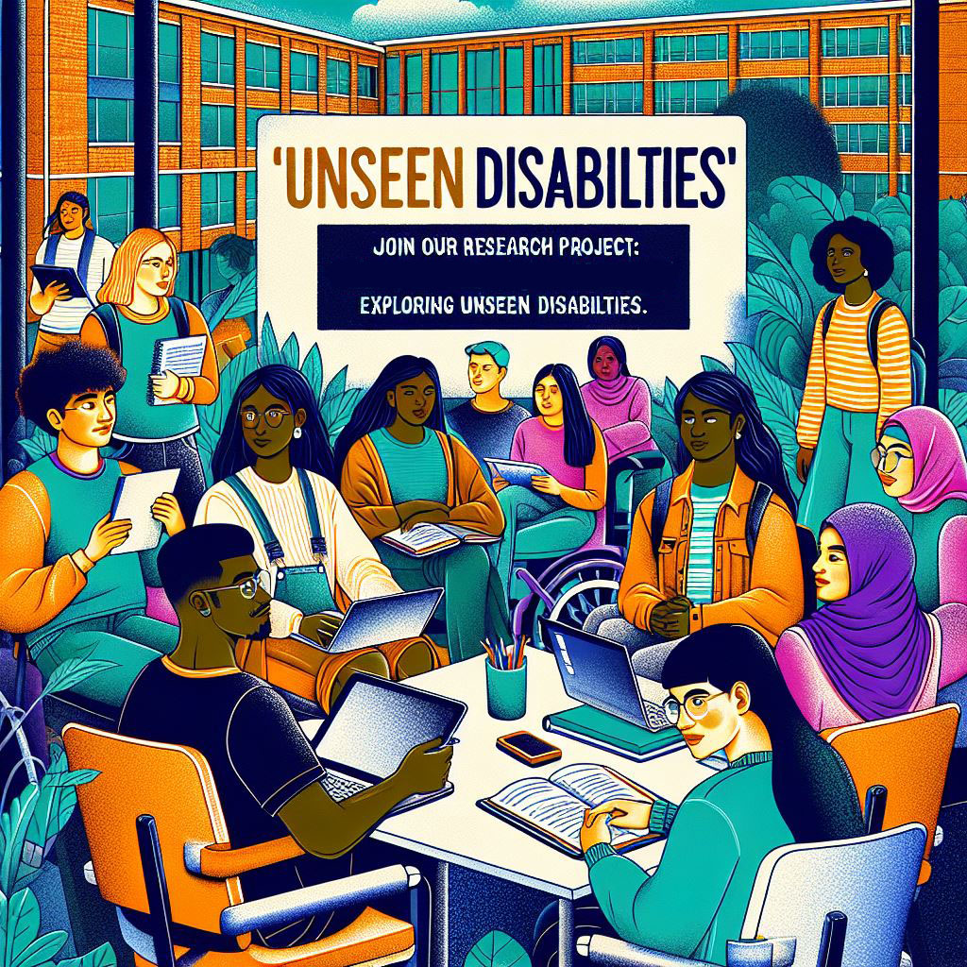

Join Our Research Project: Exploring ‘Unseen’ Disabilities
Dear Students,
We are excited to invite you to participate in an important research project aimed at discussing and exploring ‘unseen’ disabilities. This project seeks to understand the diverse experiences and challenges faced by individuals with disabilities that are not immediately visible.

Why Participate?
- Share Your Story: Your unique perspective is invaluable in helping us understand the full spectrum of ‘unseen’ disabilities.
- Raise Awareness: Contribute to raising awareness and fostering empathy within our community.
- Make a Difference: Help develop inclusive solutions and support networks for those with ‘unseen’ disabilities.

What to Expect:
- Interactive Discussions: Engage in meaningful conversations with fellow students and researchers.
- Creative Activities: Participate in activities designed to express and document your experiences.
- Confidential and Respectful Environment: Your privacy and comfort are our top priorities.

How to Join:
- Sign Up: Visit [insert sign-up link or location] to register your interest.
- Information Session: Attend our information session on [insert date and time] to learn more about the project.
- Contact Us: For any questions, please contact [insert contact information].
We look forward to your participation and to hearing your valuable insights. Together, we can make a difference!
Best regards,
[Your Name]
[Your Position]
[Your Contact Information]
[Institution/Organization Name]

